**CAR DEALER DATASET**

**DATA CLEANING USING MYSQL**

1. **Schema named ‘CARS’ created**

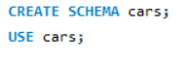

1. **Data Discovery**

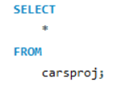

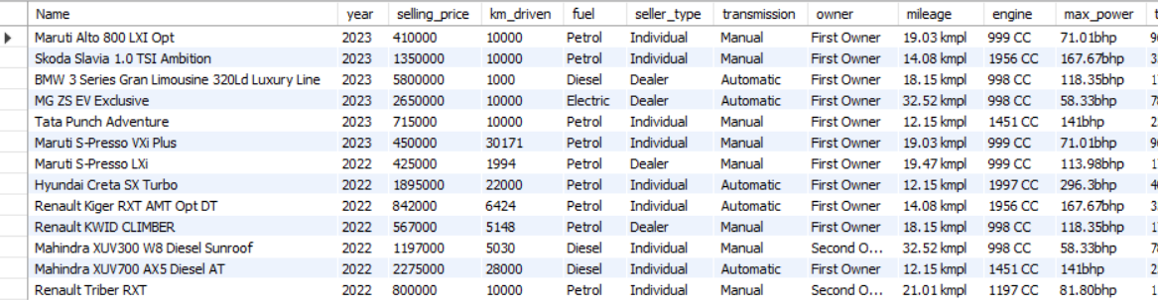

1. **Check datatypes of individual columns of the cars table**

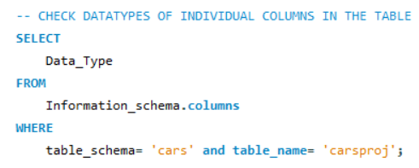

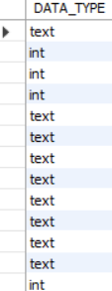

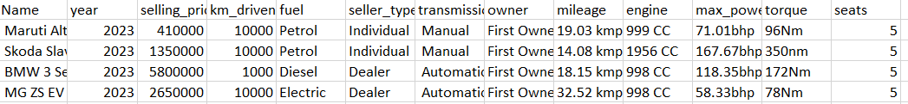

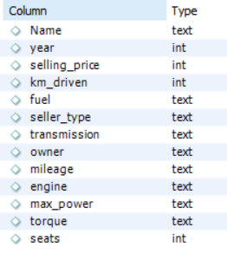

No datatype mis-match

1. **Check for missing rows in each column**

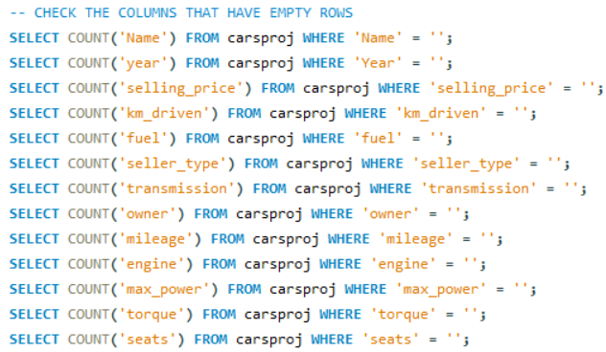



No missing rows

1. **Check for data inconsistencies**

The column ‘torque’ contains data with inconsistency in the units. Therefore, only the numeric value was extracted and separately added in a new column. The unit ‘Nm’ was concatenated to the torque value.

1. Unit mismatch

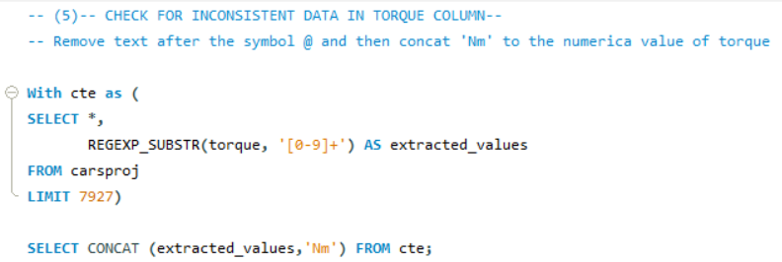

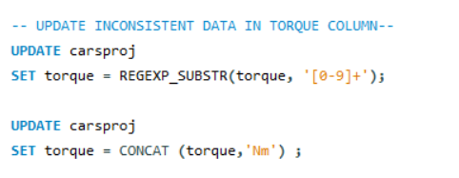

1. **Check for duplicate rows**

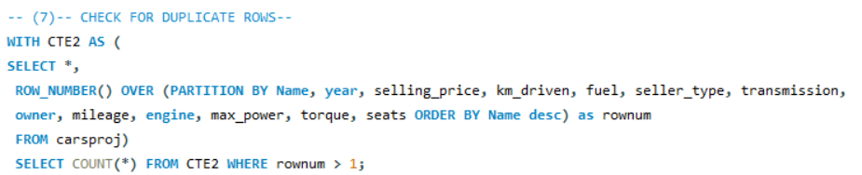



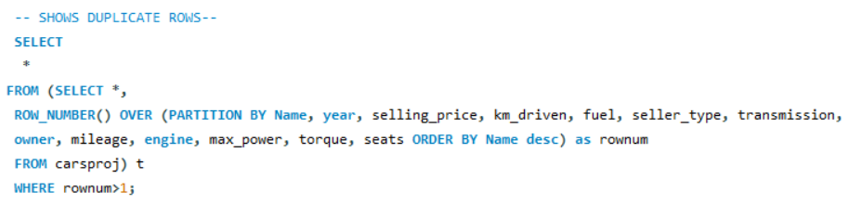

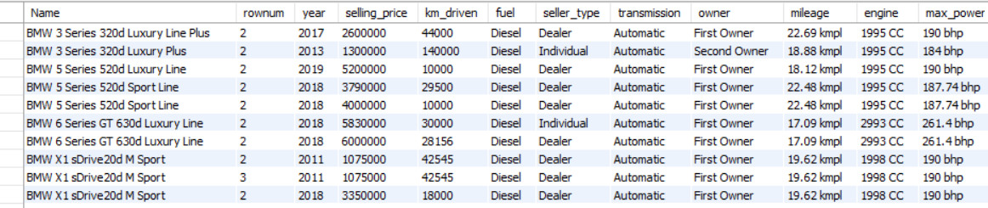



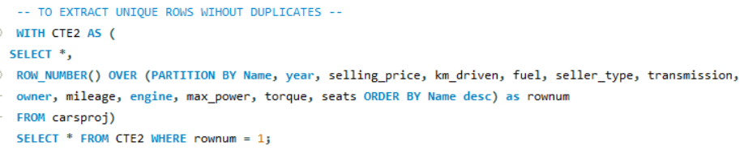

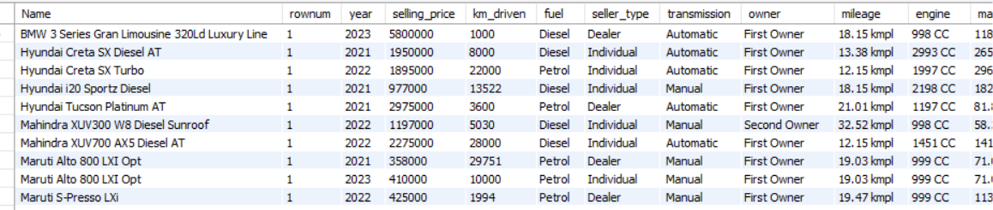



To display table with unique 6738 rows

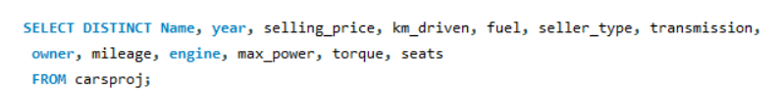

1. **Check for data inconsistencies in the unique rows**

* **km_driven** data irrelavant for a single record. Hence it need to be removed

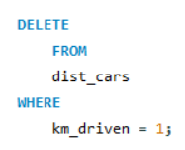



A row containing max_power as only unit ‘bhp’ and torque as ‘NULL’ is unnecessary to be included. Hence to be removed.

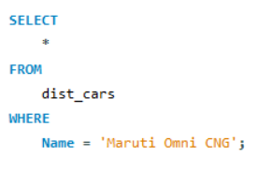



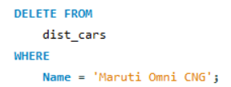







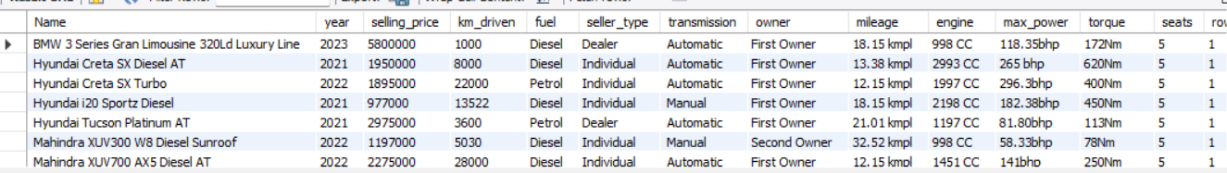

Delete column named rownum

